

How to be included in
Orleton Village Magazine

This magazine will be published on the first day of each month on the Village Website: www.orletonvillage.co.uk. Notification of publication, together with a link, will be given on Nextdoor and Orleton Village Chat (Facebook)

Articles of general interest, club or association reports and advertisements for community events may be included without charge. Commercial advertisements are charged, dependent on size. (Rates available on request from: orletonmagazine@gmail.com)
Small private sale advertisements may be accepted without charge if space allows
Orleton Village Hall

Ideal venue for family events, parties, weddings, concerts, dances,
training courses, drama performance, exhibitions, classes and craft fairs.
Large hall (160 seating capacity) with proscenium stage, theatre lighting and sound system, electric piano, video projector and radio mike.
Additional small hall (50 capacity)

Superb five star rated kitchen, cutlery and crockery. Large car park.Free Wi-Fi

Also tables, chairs and marquee available for hire for garden parties

For bookings /quotations: bookings@orletonvillage.co.uk
Tel 01568 780583

All content is accepted at the discretion of the editorial team. Articles that are disrespectful or prejudicial will not be accepted.

Copy should be submitted as Word or PDF files. If hard copy is submitted there may be a charge for scanning and input.

All copy must be accompanied by the name, address and telephone number of the author, although this will not be included unless incorporated into the article.
Articles for publication should be emailed to: orletonmagazine@gmail.com by the 20th of the month prior to desired publication

Editorial

Orleton Village Hall
Ideal venue for family events, parties, weddings, concerts, dances,
training courses, drama performance, exhibitions, classes and craft fairs.

Large hall (160 seating capacity) with proscenium stage, theatre lighting and sound system, electric piano, video projector and radio mike.
Additional small hall (50 capacity)

Superb five star rated kitchen, cutlery and crockery. Large car park. Free Wi-Fi

Also tables, chairs and marquee available for hire for garden parties
For bookings /quotations: bookings@orletonvillage.co.uk
Tel 01568 780583

The spike in hits on the Village Website when this magazine is published shows that we now have a significant and established readership.

We hope that we meet a local need in what we publish but if there are any gaps we would welcome your comments and suggestions for improving our magazine - Quizzes, short stories, the choice is yours!

We are still learning the publishing business.
Apologies this month go to Derek Bufton
whose monthly advert was inadvertently removed when an out-of-date advert, which shared the page, was removed in preparation for the February edition.
We will be publishing the following content:
- Reports of local activities
- Free adverts for events open to the community.
- Paid adverts from local businesses offering local services
- Free private for sale adverts
The last two categories will be limited as we do not want to swamp the magazine with advertising. Our production costs are low so only a few select adverts from local services or sale items will be accepted for publication.

Folk at the Boot

Not just folk but all genres
of music
Performers always welcome



It's always 2nd Thursday of the month at 8.00pm

Orleton Evergreens

Our February meeting is on 26th, 2:30pm Orleton Village Hall when we have one of our favourite entertainers, Steve Hollinghurst, joining us to deliver ‘Popular Songs’.

The subs remain at £12 for the year with the revised £4 entry, £6 for visitors.

Contact Sue Turner
Sue.a.turner@gmail.com

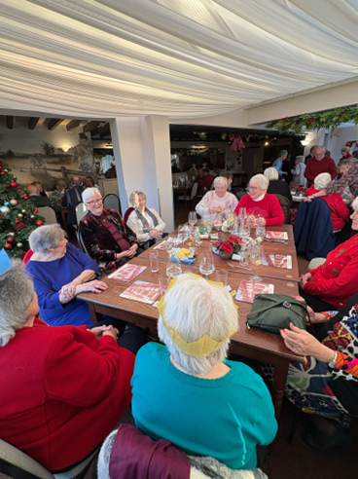



Orleton Art Group

Are you artistic or do you fancy trying your hand at painting and drawing? If so come and join us. We meet Wednesday afternoons from 2.00pm until 4.30pm at Yarpole Village Hall.
For more information please email Larry Turner, laurencepturner@gmail.com
or Geoff Trotter, geoffrey.a.trotter@gmail.com
Or telephone Larry on
01584 831324

Orleton WI

WI had a demonstration of the art of decoupage by our President Sue Copson.
Decoupage the art of decorating objects with paper cutouts began in 12th century China evolving from Siberian felt art, and spread to Europe by the 17th century becoming a

popular imitation of expensive lacquerware called "lacca povera". It flourished in 18th century French and English courts and the Victorian era as a fashionable hobby, gaining widespread appeal with printing advancements and saw a revival in the 1960's DIY movement.
Sue brought along some of the many items she had beautifully decorated including Christmas decorations,
vases, lamps and a small table showing how versatile this craft can be.
Orleton WI members then had the opportunity to try their hand at this craft, creating pretty vases using jam jars and paper napkins. Our thanks go to Sue for showcasing this enjoyable craft.

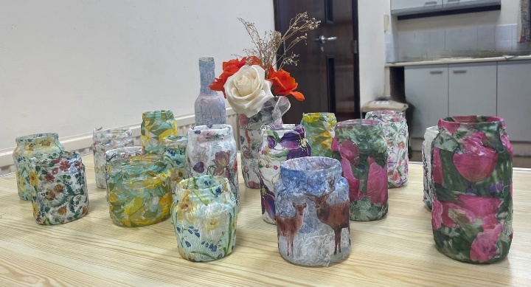

Forthcoming Event

On Monday February 9th at 2.30pm, we welcome Amy Johnson from St Michaels Hospice Hereford, who will give us with an insight into the wonderful palliative care services they provide.

Visitors are always welcome and, on this occasion, we are inviting everyone to bring along a donated item for the hospice to sell for their


funds. Ideas include a household item, a book or item of clothing; all will be gratefully received.

We have a raffle; £1 a ticket and free refreshments. Visitors £4.
For further information please contact Sue Copson (President) on 01568 780956





Orleton Coffee Morning needs you!

Orleton holds a weekly coffee morning at our village hall on a Wednesday morning at 10.30am–12 noon.

We offer homemade bakes, hot drinks, and a friendly informal place to meet and chat.
We would love to welcome a few more folk onto our team of helpers.

Do you have a favourite bake you may like to share with us?

Enjoy meeting and greeting folk, and maybe you would like to help at a session on an occasional basis?
WE WOULD LOVE TO HEAR FROM YOU!

Please contact our Chair Cathy Hardwick via email at cathy.hardwick@hotmail.co.uk





Ludlow Concert Band

By popular request this impressive band is to return to Orleton Village Hall on 7th March with their wide repertoire of classics, big band numbers and popular music.
Tickets inc light refreshment from Orleton Village Shop & post Office £10 (£12 on the door)



Safer Neighbourhood Team

Did you know we have a specialist team that deals with Rural Crime?

Types of Rural Crime:

Acquisitive Crime: Acquisitive crime in rural areas often involves the theft of high-value equipment and machinery, such as tractors, quad bikes, and farming tools. Other offences in this category include the theft of fuel and livestock

Wildlife Crime: Includes hare coursing, hunting with dogs, poaching, and interference with protected species such as bats, badgers and birds of prey.

Equine and Livestock Crime: Such as theft of animals, (horse) tack theft and livestock worrying.

Heritage Crime: Crimes that damage heritage assets, including lead theft from churches, damage to monuments, and illegal metal detecting.

The rural crime team work closely with safer neighbourhood teams like ours, to offer crime prevention advice and reassurance visits to our communities.

PCSO Stephanie Harper 6440
Police Community Support Officer | SNT Leominster | West Mercia Police
Enterprise Way, Leominster, Herefordshire, HR6 0LZ
Mobile: 07773043483
Direct Dial: 01432 347217 Ext. 7723019
Team mail: leominster.snt@westmercia.police.uk

Gardening for Biodiversity by Chris Evans

To say we are on the verge of ecosystem collapse is an understatement. It’s already happening in areas around our villages and in our gardens. Green deserts of closely mown, sprayed lawns, beds of hybrid flowers with little nectar for wildlife back onto similar monoculture farm deserts of highly tilled, engineered and sprayed crops. Small “islands” of biodiversity are refuges, but when they’re too small, a tipping point is reached and populations collapse, having effects throughout the food chain. I remember in my youth in the village of Luston, many properties had “neglected” orchards behind them, havens for wildlife, teeming with insects, birds and mammals. One by one they have been “tidied up”, cleared and usually built upon. In our comfy rural settlements, the story is of declining bio-diversity and wildlife populations.

But there are lots of things we can do, from small scale, easy interventions to more radical out-of-the box ideas, and bigger policies that parish, county and national councils need to take up.

- Lots of websites tell you what you can do in “ten top tips for biodiversity”, but rarely the first and most important action – stop doing harmful things: spraying pesticides, fungicides and herbicides; less tillage/bare soil (use mulching/min. till); less monocultures.
- Mow long and less – not short, or often – leave islands of no/less mown
- Provide habitat for breeding and foraging – think diversity, create microclimates: ponds (even washing up bowl-sized), rock piles, wild undisturbed areas; planks, sheets of tin on the ground; log piles, brash piles; leaf piles, compost piles, bug hotels, hedgehog hotels; bird boxes, bird baths, bird feeders.
- Provide food sources (start at the base of the pyramid: plants with leaves, flowers & seeds) – rich soil and organic matter -> food for bacteria & fungi -> food for insects -> food for birds, mammals
- Understand what you have (resources) – connect with nature; observe

Attracting insects involves planting wild flowers, herbs, fruit trees, and other useful species. Here are some examples:

Ground cover: clover, trefoil, yellow rattle, lawn chamomile, thyme, vetch, pansy, wild garlic, sedum, violets, crocus

Herb layer: coneflower, marjoram, oregano, hyssop, rosemary, lavender, zinnia, nasturtium (also a climber), comfrey, borage, cosmos, mints, lemon balm, ox-eye daisy, poppy, lupin, calendula, marigold, sage, mountain mint, fennel, hypericum, rose

Shrub layer: sunflower, buddleia, tansy, currants/soft fruit, nettle, Oregon grape (Berberis), Cotoneasta, foxglove, mullein, teasel

Tree layer: crab apple, serviceberry, Eleagnus, Buckthorn, hawthorn, Strawberry tree (Arbutus), elder, rowan, lime, wild cherry, birch, holly

Vines/climbers: passion flower, clematis, honeysuckle, ivy, wisteria, rambling rose

Plant borders, beds, corners, verges. Most pollinator/insect-friendly flowering plants are also going to give a WOW benefit of beautiful flowers. Don’t just get hybrids bred for colour though – they often aren’t good nectar sources like native wildflowers are.

It’s no longer enough to think that “our” garden is OK as a haven. There needs to be extensive, wide corridors of wildlife-friendly habitat within and around cities, towns and villages. Everyone has a part to play.



Janet’s Jacket Potatoes
will be visiting Orleton Village Hall Car Park on
Monday 2nd February from 5.30 until 7.30 pm.
Select on the night or pre-order on the Facebook site

Should this prove popular it may become a regular event.

Orleton Charity Quiz Nights

Teams of up to six members. 7.30 for a 8.00pm start
Pre-booking of tables at:
the Boot (01568 780228) and the Maidenhead (01584 831686)
is strongly advised
March 10th Village Hall
April 14th Maidenhead
May 12th Boot Inn
June 9th Village Hall

September 8th Maidenhead
October 13th Boot Inn
November 16th Village Hall
December 8th Maidenhead
All proceeds go to support local organisations in Orleton Village or
recognised National Charities.
Special Event: John Robbins Memorial Quiz at Orleton Village Hall
on a Saturday evening. Watch for the date!



FREE
Ten Lever arch files and Six ring binders.
All used but in good condition.

Contact:
01568 780583

Polite Notice

Would the dog owner who regularly allows their dog to
foul the pavement at the top
end of Millbrook Way within metres of the dog bin please
use the bin for the purpose
for which it is intended.

Pick it up!


Report from your County Councillor
Dan Hurcomb

Congratulations to the committee and volunteers of the Recreation Ground on the opening of the new pavilion. A significant amount of time, effort and resource that has gone into making it happen and I hope that it will become a cherished community facility in the years ahead.

The January Parish Council meeting was well attended given the topics up for discussion and I was pleased to be able to update residents on the progress that has been made on local issues over the past few months. Of particular interest was the proposed “flood alleviation scheme” which is now moving into a critical phase – I hope to be able to share more details in subsequent issues of this magazine.

Parish Councillors give up their time and energies for free to represent the interests of local residents and I would like to publicly thank former Cllrs Bishop, Gittings and Rogers for their dedication and hard work during their time serving the community. I hope that the vacancies their resignations have created will be filled quickly so the Parish Council can return to normal service as soon as possible.

On a final note, in December I was asked to put forward roads to be considered for the 26/27 Highways Resurfacing Program. I can confirm that I have put forward Green Lane, Tunnel Lane, B4362 from Comberton to the Shropshire boundary, The B4361 from Portway to Ashley Moor turn, and Leys Lane (Ashley Moor). The budget is finite so there is no guarantee these will be done but they will be inspected as part of the request.

As always if you have any concerns, issues or would just like a chat, then please do get in touch.

Dan Hurcomb
dan.hurcomb@herefordshire.gov.uk
07837726821

Open the Book 

Could you be a storyteller?

OtB is an exciting storytelling project where a group of people share Bible stories with the children in Orleton school on a Tuesday morning each fortnight. The stories are interactive and the children love to help deliver the 10–15-minute scripted Bible stories as part of Collective Worship.
We are currently a small team made up of trained and safely recruited volunteers from our local churches and organisations who follow the Bible Society Open the Book Code of Practice.
A Bible story well told has the power to spark imagination, inspire exploration, give hope, create a smile, teach important lessons and connect generations.
We would love to hear from you if you feel you could join our group.
The children and staff make us SO welcome! Please contact the school directly.
01568 780366 or email at: admin@orleton.hereford.sch.uk
Thank You.

.


Orleton History Group

On 24th January, we were treated to an entertaining and fascinating talk from Janine Bryant on “Bitten by Pigs and Struck by Lightning: How Coroners Rolls can Expand our Knowledge of Life in the Late Middle Ages”. Look out for a full report in the next edition of Grapevine.

Our upcoming talks and events are:

Saturday 28th February 2.30pm, St George’s Church:
The Medieval Chests of St. Georges’ Church at Orleton: their Use, Significance, Construction and Conservation”, by Rachel
Sycamore, Furniture Restorer and Conservator. Rachel will talk about the two unique and important medieval chests housed inside the church at Orleton. She will explain how they were
made and why, and what their meaning would have been to the medieval church and its parishioners. Having recently carried out conservation on the two chests, Rachel will talk through
her methods in preserving them both for future generations.

Saturday 28th March, 2.30pm, St George’s Church: An overview of St George’s Church history John Berry and Liz Mackay lead us through an overview of the twists and turns of the history of St George’s Church, looking at how the architecture, religious, social and political contexts changed.

Sunday 26th April, timings TBC: St George’s Festival celebrations, with the traditional Mummers’ play, Morris Dancing, games, and much more! Look out for publicity in future editions of
Grapevine and round the village for more details.

You can also read reports on previous talks at the history group page at: www.stgeorgesorleton.org.uk (and then click on ‘Orleton History Group’).

If you would like further information about the group, please contact Liz Mackay on e.e.mackay@gmail.com,
or 07484 679671

Orleton Craft Group

Our February meetings are on Thursdays 5th & 19th, 1:30 to 4:30 or any time in between, at Orleton Village Small Hall.

Bring along any craft you are working on and enjoy a chat, tea and cake!

Sue & Diane
sue.a.turner@gmail.com



Victoria Allen Funeral Services
(Est 2006)

An Independent Family Business

Private Chapel of Rest

Pre-Paid and Pre-Arranged Funeral Plans

Covering All Areas

Home Visits Always Available

24 Hour Service

Victoria Allen
8 Charlton Rise, Ludlow, Shropshire, SY8 1ND
01584 879035

Graham Bradley
6 Orchard Close, Kingsland, HR6 9QS
01568 708022

Email: vafs@btinternet.com

www.vallenfuneralsludlow.co.uk




Programme 2026



On Tuesday 24th February Richard Cave will tell us about ‘Melcourt Peat Free Composts’.
Gardeners now have having increasing concerns about peat, which is still being used in gardens, and the environmental damage caused by its extraction. Melcourt developed versatile 100% peat free composts suited to many uses which Richard will explain and answer questions on.
Tuesday 31 March Marion Stainton
Raised bed vegetable growing
Tuesday 28 April Nicola Hope
Tales from the potting shed
Sunday 17 May 2026
Plant Sale
Tuesday 26 May Timothy Walker
Scent in the garden

Tuesday 30 June Alun & Jill Whitehead
Hidden gardens of Herefordshire
Saturday 15 August
Annual Show at Village Hall
Tuesday 29 September Bill Laws
Apples, pears and the Herefordshire Pomona
Tuesday 27 October Pip Smith
In the bleak midwinter
Tuesday 24 November Diann Dowell
The history of mistletoe
Visitors welcome to all talks £2.50
Meetings take place at 8:00 pm on the last Tuesday of the month, mostly in Orleton Village Hall
Refreshments from 7:15pm

email: orletongc@hotmail.co.uk
ww.orletongardeningclub.co.uk

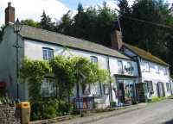
Orleton Village Shop
& Post Office

Shop Post Office
Mon- Fri 0745-1800 0745-1800
Sat 0830-1230 0830-1230
Sun 0830-1230 Closed

Grafted Apple trees
2-3 year old named dessert, cookers, cider varieties
In pots - £20 (discount for bulk)
Trees in pots are easy to look after until
you’ve decided where to plant them!
Discovery, Ashmead’s Kernel, Russets, and many more...
Root stock: M25 vigorous; M111 & MM106 semi-vigorous
Advice on tree/orchard management also provided
Contact Chris, 07939 864732
Waterloo Farm, SY8 4JG
applewoodcourses@yahoo.com
www.applewoodcourses.com





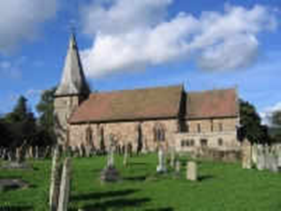
Orleton Church & Chapel News

After the celebrations of Christmas, January has been a relatively quiet time.
In addition to the usual services and meetings, on 11th January, we had the joy of a Family Epiphany Service where we had a drama to Meet the Kings, followed by party games and a party tea.
On 25th January, we celebrated Jesus’s gathering of his disciples through craft activities (followed by more activities and snacks!).
Moving into February, we see the start of Lent. Look out for details elsewhere in this issue of the Lent activities:
- Pancake Racing: Sunday 15th February, 3pm at The Maidenhead;
- Ash Wednesday service: 18th February, 6.30pm, St George’s Church
- Lent discussion group: Wednesdays 25th February, 4th March, 11th March, 18th March, and 25th March, all at 7.30pm in Chapel

Details of our Easter services will be in March’s newsletter, and on posters round the village.

Updates on our other activities, including an update on our Family Services, the Orleton History Group, Singing for Fun, Open the Book, food bank donations, and the 100 Club winners, can be found in our full newsletter, at: https://stgeorgesorleton.org.uk/news/news , and click on ‘Church & Chapel News’.

For further information about Church, Chapel, services or activities, or if you would like to get
involved either socially or as a member of the congregation then please contact:
Matthew Burns (Vicar, St George’s):
01568 614399,
teamvicarwest@leominsterteam.org.uk

Rev Denise Hargreaves (Methodist Minister): 01584 318628, dkah26@gmail.com,
Ludlow Church Office 01584 879233
Also, why not check out the St George’s website: https://stgeorgesorleton.org.uk.


Orleton Good Neighbour Scheme

The Good Neighbour Scheme supports our community using a team of volunteers to help people who are experiencing difficulty in their own homes essentially, by just doing things that good neighbours do for each other.

Examples of how the scheme can help:
- Fetching prescriptions
- Occasional lifts to the surgery or hospital
- Shopping and running errands, such as posting a letter.
- Practical tasks around the home, such as changing a light bulb or hanging a picture

Contact Number 07467 535503



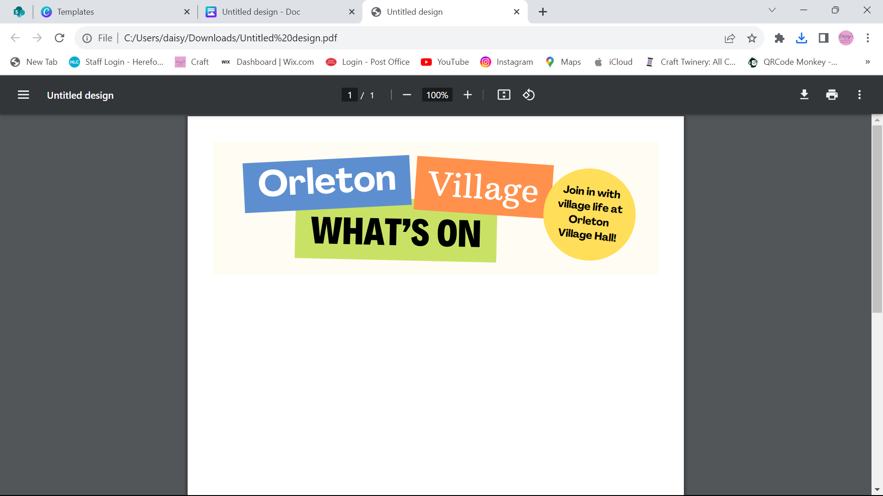
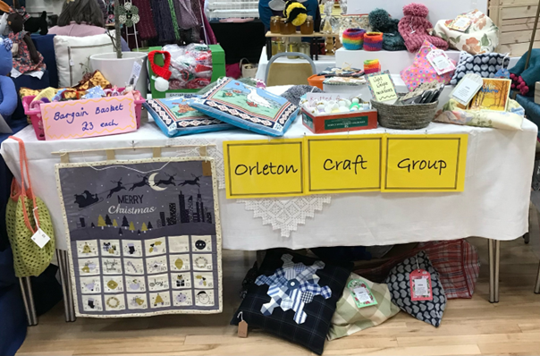

Happy New Year from Orleton Village Hall

Dates for your diary…
Saturday 7th March – Ludlow Concert Band return to the Village Hall

The REGULARS Monday – Thursday …

Orleton Toddlers Every Monday morning 10-11:45am
Contact: Bethan 07534 726222 or Charlotte 07964 981036
Orleton WI 2nd Monday of the month, October to March at 2:30pm
Contact: Sue Copson susancopson934@gmail.com
Rainbows Every Tuesday in term time 4:30-5:30pm
Contact Kaye Harrison kayemharrison@yahoo.co.uk
Gardening Club Last Tuesday of the month 7:30-9:30pm
Contact: Monica 01568 613361 orletongc@hotmail.co.uk
Coffee Morning Every Wednesday at 10:30am-12:00 (Closed in August)
Contact: Cathy Hardwick cathy.hardwick@hotmail.co.uk
Library Last Wednesday of the month at Coffee Morning 10:30-11:45am
Contact: Sue Rogers 01584 831514
Sequence Dancing 3rd Wednesday of the month – 2-3pm
Contact: Amy Whitby amyelwynwhitby@gmail.com
Evergreens Last Thursday of the month – 2-4pm
Contact: Sue Turner sue.a.turner@gmail.com
Craft Group 1st and 3rd Thursday of each month 1:30-4:30pm (No sessions in August) Contact Sue Turner 01584 831324 sue.a.turner@gmail.com
Table Tennis Every Thursday at 7:30pm
Contact: Geoff Lewin geoffnlewin@gmail.com

Hall available for private bookings
Contact Booking Secretary on 01568 780583 or bookings@orletonvillage.co.uk

To include your event or amend an entry in the Dairy,
Please Email orletonhandmade@gmail.com by the 12th of the month
All entries are, as far as we know, correct at the time of going to print.

Contacts

Allotments Assoc | Nick Ford |  | 01584 875834
Art Group | Geoff Trotter | Geoffrey.a.trotter@gmail.com
Caring for God’ Little Acre | Barbara Mark |  | 01568 780842
Church Wardens | Liz Mackay  John Berry |  | 07484 679671  01568 780321
Doctors |  |  | 01584 831300
Evergreens | Sue Turner | sue.a.turner@gmail.com | 01584 831324
Gardening Club | Nick Russel |  | 01568 780678
Good Neighbour Scheme |  |  | 07467 535503
Herefordshire Councillor | Cllr. Dan Hurcomb | dan.hurcomb@herefordshire.gov.uk | 07792 882147
Land Drainage Group | David Lane |  | 01568 78036
Orleton Footpath Maintenance Volunteers | Matin Bradford | emimart@hotmail.com | 01568780151
Orleton Relief in Need | Barry Rogers |  | 01584 831514
Orleton Junior Football Club | Mel Williams | cherry.brook@me.com | 07511 920515
Orleton Toddlers | Bethan Jenkins | Bethan.I.edwards@hotmail.co.uk | 07534 726222
Orleton Young Farmers Club | Bell Beaumont | orleyonyfc@hotmail.com
Parish Council |  | clerk@orleton-pc.gov.uk
Pre-School | Tara Morris |  | 01568 780143
Primary School |  | admin@orleton.hereford.sch.uk | 01568 780366
Primary School PTA | Nicola Goodman | nicolagoodman1989@gmail.com
Rainbows | Carly Morgan |  | 07788 236628
Recreation Association | Graham Shaw |  | 01568 780783
Village Hall |  | bookings@orletonvillage.co.uk | 01568 780583
WI | Sue Copson |  | 01568 780956

